Lifecycle Event

Lifecycle Event – Voyager Employee Conversion

Event Configuration
Attribute | Value
Name | Voyager Employee Conversion
Type | Attribute Change

Event Criteria
The lifecycle event is triggered when the following conditions are satisfied:
- Previous WorkerType must be "C" and the new WorkerType must be "E".
- Assignment Status Type Code must be equal to "Active - Payroll Eligible".
- Assignment Action is not equal to “REHIRE”.
This lifecycle event represents a conversion of a Contractor (C) to an Employee (E) and triggers the Voyager Conversion Workflow to update access, roles, and accounts accordingly.

Lifecycle Event – Voyager NEP Conversion

Event Configuration
Attribute | Value
Name | Voyager NEP Conversion
Type | Attribute Change

Event Criteria
The lifecycle event is triggered when the following conditions are satisfied:
- Previous WorkerType must be "E" and the new WorkerType must be "C".
- Assignment Status Type Code must be equal to "Active - No Payroll".
- Assignment Action is not equal to “ADD_CWK_WORK_RELATION”.
This lifecycle event represents a conversion of an Associate (E) to an NEP (C) and triggers the Voyager Conversion Workflow to update access, roles, and accounts accordingly.

Flow Chart

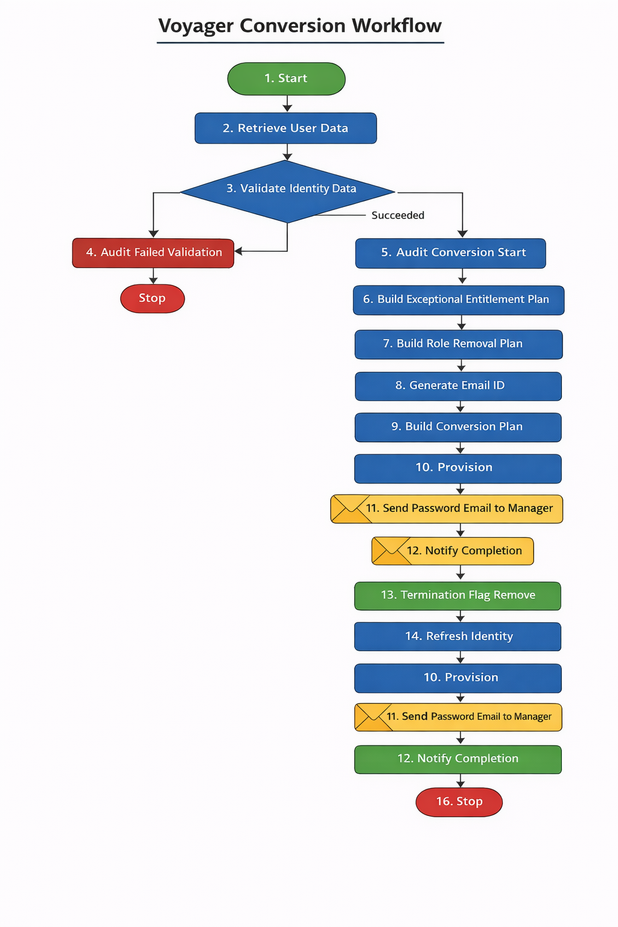

Step Summary

Voyager Conversion Workflow – Step Summary
Step No. | Step Name | Description
1 | Start | Initiates the workflow when the Voyager Employee Conversion lifecycle event is triggered due to the worker type change from Contractor (C) to Employee (E) or Employee (E) to Contractor (C)
2 | Retrieve User Data | Retrieves required identity attributes such as employee type, assignment action, assignment status, hire date, first name, last name, and employee ID for workflow processing.
3 | Validate Identity Data | Validates whether the retrieved identity attributes contain any null or empty values and stores missing attributes in the validationResult list.
4 | Audit Failed Validation | If validation fails, creates an audit event "Data Validation Issue - Employee Conversion Event" and "Data Validation Issue - NEP Conversion Event" based on current workertype including the list of missing attributes and terminates the workflow.
5 | Audit Conversion Start | If validation succeeds, creates an audit event "Initiated - Employee Conversion Event" and "Initiated - NEP Conversion Event" based on current workertype capturing the retrieved identity attributes.
6 | Build Exceptional Entitlement Plan | Evaluates the user’s exception entitlements, determines which accounts should be deleted, which entitlements should be removed, and which should be retained based on the Voyager Conversion Configuration custom object.
7 | Build Role Removal Plan | Identifies and removes non-birthright business roles and unnecessary IT roles while ensuring required technical roles remain assigned.
8 | Generate Email ID | Generates a unique employee email address using helper functions and updates the identity’s email attribute in SailPoint.
9 | Build Conversion Plan | Prepares provisioning instructions to update existing Active Directory accounts or create new ones, including updating UPN, email attributes, password reset, and mailbox priority attributes.
10 | Provision | Executes the provisioning plan using the Voyager LCM Provisioning Workflow and creates a ServiceNow incident if any errors or warnings occur.
11 | Send Password Email to Manager | Sends the generated temporary password and account information to the user’s manager after successful provisioning.
12 | Notify Completion | Sends a conversion completion notification to the user’s manager including provisioning status and any errors or warnings encountered.
13 | Termination Flag Remove | Clears the identity attributes terminationStatus and terminationStatusDate as the user is now active as an employee.
14 | Refresh Identity | Performs an Identity Refresh to synchronize identity attributes and update application account links based on target mappings.
15 | Audit Conversion Completion | Creates an audit event "Completed - Employee Conversion Event" and "Completed - NEP Conversion Event" based on current workertype recording the successful completion of the conversion process.
16 | Stop | Ends the workflow after provisioning, notifications, audit logging, and identity synchronization are completed.

Workflow Description

Workflow: Voyager Conversion Workflow

1. Start
The workflow begins when the Voyager Employee Conversion lifecycle event is triggered due to a change in the worker type attribute from Contractor (C) to Employee (E) or Employee (E) to Contractor (C).

2. Retrieve User Data
This step retrieves the required identity attributes from SailPoint to support the conversion workflow.

Retrieved Identity Attributes
The following attributes are collected and stored as workflow variables:
- employeeType
- assignmentAction
- assignmentStatusTypeCode
- hireDate
- firstname
- lastname
- employeeId
These attributes are used for validation, auditing, account provisioning, and notification processes during the workflow.

3. Validate Identity Data
This step ensures that all required identity attributes have valid values before continuing with the conversion process.

Validation Process
- The workflow checks whether any of the retrieved attributes are null or empty.
- If any attributes are missing, their names are added to a list called validationResult.
This list is used in subsequent steps to determine whether the workflow should proceed or terminate.

4. Audit Failed Validation
If the validationResult list contains any attributes (indicating missing data), the workflow performs the following actions:
- Creates an Audit Event with the name:
"Data Validation Issue - Employee Conversion Event" or "Data Validation Issue - NEP Conversion Event" based on current workertype.
- The audit event includes the list of missing attributes stored in validationResult.
- The workflow then terminates, preventing any incorrect provisioning actions from occurring due to incomplete identity data.

5. Audit Conversion Start
If the validationResult list is empty, the workflow proceeds with the conversion process.
An Audit Event is created to record the initiation of the conversion process.
Audit Event Name:
Initiated - Employee Conversion Event

Initiated - NEP Conversion Event

The event captures all retrieved identity attributes to maintain a traceable record of the conversion process.

6. Build Exceptional Entitlement Plan
This step builds a provisioning plan that handles exception entitlements, which are permissions granted directly to users outside of standard role assignments.

Configuration Retrieval
The workflow retrieves the Custom Object:
Voyager Conversion Configuration
This configuration contains two key components:
- Delete Account List
  - Applications where the user account should be completely removed during conversion such as
    - EPM Cloud EDMCS,
    - EPM Cloud Planning,
    - EPM Cloud FCCS,
    - EPM Cloud ARCS,
    - EPM Cloud EPCM
- Retain Entitlement Map
  - Specific entitlements that must remain assigned to the user even during conversion such as
    - Duo Groups: Based on the user's Primary AD Account.
    - UKG: Initial Role

Entitlement Processing Logic
The workflow evaluates each exception entitlement assigned to the user.

Account Deletion
If the entitlement belongs to an application listed in the Delete Account List:
- The workflow adds an Account Delete request to the provisioning plan.
- All further entitlement checks for that application are skipped.

Entitlement Removal
If the account is not scheduled for deletion:
- A Modify request is created for the application account.
- Individual entitlements are evaluated for removal.
Before removing an entitlement:
- The workflow checks the Retain Entitlement Map.
- If the entitlement appears in the exclusion list for the application, it is retained.
For all other entitlements:
- An AttributeRequest with the Remove operation is added to the provisioning plan.
All deletion and removal actions are aggregated into the final ProvisioningPlan.

7. Build Role Removal Plan
This step removes roles that are no longer applicable after the user's conversion from contractor to employee.

Business Role Evaluation
The workflow evaluates all assigned business roles.
- If a role is not marked as a Birthright role, it is added to a removal list.

Technical Role Dependency Check
The workflow invokes the helper function:
getRequiredRoles
This function determines which IT roles are still required by the remaining business roles.
This ensures that technical roles are not removed if they are still required.

IT Role Evaluation
The workflow evaluates all detected IT roles.
- If an IT role is not required by any business role, it is marked for removal.

Provisioning Plan Construction
A Modify request is created targeting the IIQ application.
The following attribute operations are added:
Attribute | Operation
assignedRoles | Remove
detectedRoles | Remove

Entitlement Cleanup
When IT roles are removed, the workflow explicitly sets the parameter:
deassignEntitlements = true
This ensures that all underlying permissions associated with the role are also removed from connected systems.
The role removal requests are appended to the existing ProvisioningPlan.

8. Generate Email ID
During conversion, the user may require a new employee email address.

Email Generation Process

Prefix Generation
The workflow calls the helper function:
frameEmailPrefix
This function constructs the email prefix based on attributes such as:
- First name
- Last name
- Initials

Suffix Assignment
The helper function:
frameEmailSuffix
determines the correct domain suffix.
Example:
@ascension.org


Email Address Creation
If both prefix and suffix are valid:
- The workflow calls:
generateEmailAddress
- 
The function checks existing email addresses to ensure uniqueness.
- If a conflict exists, a numeric suffix may be added.
Example:
j.doe@ascension.org
j.doe1@ascension.org


Identity Attribute Update
Once generated:
- The email value is assigned to the identity's email attribute.
- The update is committed using:
context.saveObject()
context.commitTransaction()
This ensures the email is permanently stored in the SailPoint database.

9. Build Conversion Plan
This step prepares provisioning instructions for Active Directory account updates or creation.

Domain Mapping Retrieval
The workflow retrieves the Ascension-Custom-AD-DomainMapping custom object.
This configuration identifies:
- Target Active Directory Application
- Target Active Directory OU
based on the user’s domain or market.

Existing AD Account Synchronization
The workflow evaluates all linked Active Directory accounts.
For each active AD account:

Email & UPN Update
The workflow updates:
- userPrincipalName
- mail
to match the newly generated identity email.

Password Reset
A new temporary password is generated using the:
AD Default Password Policy


Mailbox Attribute Management
The attribute:
msExchExtensionAttribute35
is used to designate account priority.

Scenario | Value
Primary AD domain | Primary
Secondary AD domain | Secondary

Mail Attribute Cleanup
If the existing AD mail attribute differs from the identity email:
- A request is generated to remove the old email value.

New AD Account Creation
If the user does not have an account in the target AD domain:
- A Create Account request is generated.
- The attribute msExchExtensionAttribute35 is explicitly set to Primary.

10. Provision
The complete ProvisioningPlan is executed using:
Voyager LCM Provisioning Workflow
After provisioning:
- The ProvisioningResult from the ProvisioningProject is evaluated.
- If errors or warnings are detected:
A ServiceNow Incident Ticket is automatically created containing:
- Identity information
- Request details
- Error messages

11. Send Password Email to Manager
Upon successful provisioning:
- An email notification containing the temporary password information is sent to the user’s manager.
This ensures secure delivery of the user’s credentials.

12. Notify Completion
A workflow completion notification is sent to the user’s manager.
The email includes:
- Confirmation of the conversion process
- Details of any provisioning warnings or errors detected during execution

13. Remove Termination Flags
Since the user has transitioned from contractor to employee status, any previous termination lifecycle flags must be cleared.
The following identity attributes are updated:
Attribute | Value
terminationStatus | Empty
terminationStatusDate | Empty

14. Refresh Identity
An Identity Refresh operation is executed with attribute synchronization enabled.
This step ensures that:
- Application account attributes
- Target mappings
- Role assignments
are synchronized with the updated identity profile.

15. Audit Conversion Completion
An audit event is generated to record the successful completion of the workflow.
Audit Event Name:
Completed - Employee Conversion Event

Completed - NEP Conversion Event

All retrieved identity attributes are recorded as part of the audit record.

16. Stop
The workflow ends and marks the completion of the Voyager Conversion process.

